
MACHINE LEARNING CO-04 AT1
[Document subtitle]

S.VENKATESH
192312109

1.Write a Python program to implement the K-Nearest Neighbour
(KNN) algorithm for a small dataset. Use Euclidean distance to find nearest
neighbors and classify a test instance. Allow the user to input the value of K
and display predicted class labels with accuracy.
CODE:
import math
# Construction Worker Dataset
# [Experience in years, Working hours per day]
X = [
[1, 9],
[2, 9],
[2, 10],
[3, 9],
[4, 8],
[5, 8],
[6, 8],
[7, 7],
[8, 7],
[9, 6]
]
# 0 = Low Productivity
# 1 = High Productivity
Y = [
0, 0, 0, 0, 0,
1, 1, 1, 1, 1
]
# Test data
test = [
[3, 10],
[5, 9],
[7, 8],
[9, 7]
]

# Actual test labels
actual = [0, 1, 1, 1]
# Get K from user
k = int(input("Enter the value of K: "))
predictions = []
# KNN prediction
for point in test:
distances = []
# Calculate Euclidean distance
for i in range(len(X)):
distance = math.sqrt(
(point[0] - X[i][0]) ** 2 +
(point[1] - X[i][1]) ** 2
)
distances.append((distance, Y[i]))
# Sort distances
distances.sort()
# Select K nearest neighbors
nearest = distances[:k]
# Count classes
low = 0
high = 0
for distance, label in nearest:
if label == 0:
low += 1
else:
high += 1
# Majority voting
if high > low:
prediction = 1
else:
prediction = 0
predictions.append(prediction)
# Display predictions
print("\nPredicted Class Labels:")
for i in range(len(predictions)):
if predictions[i] == 0:
print("Test", i + 1, ": Low Productivity")
else:
print("Test", i + 1, ": High Productivity")
# Calculate accuracy
correct = 0
for i in range(len(actual)):
if predictions[i] == actual[i]:
correct += 1
accuracy = (correct / len(actual)) * 100
print("\nAccuracy:", accuracy, "%")
OUTPUT:
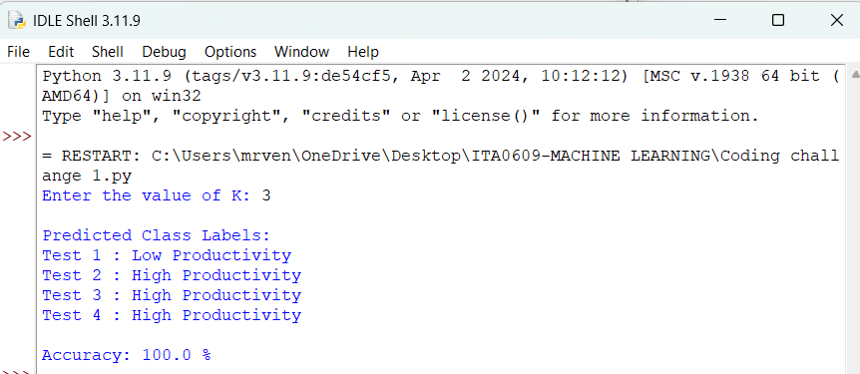
2.Write a Python program to implement Logistic Regression
for binary classification. Train the model using gradient descent and predict
outputs for test data. Display the sigmoid function output and classification
results. Evaluate the model using accuracy and discuss how learning rate
affects convergence and performance.
CODE:
import math
# Training data
# [Soil Moisture, Temperature]
X = [
[20, 34],
[25, 33],
[30, 32],
[35, 31],
[40, 30],
[45, 29],
[50, 28],
[55, 27],
[60, 26],
[65, 25]
]
# 1 = Irrigation Required
# 0 = Irrigation Not Required
Y = [1, 1, 1, 1, 1, 0, 0, 0, 0, 0]
# Initial values
w1 = 0
w2 = 0
b = 0
learning_rate = 0.1
epochs = 1000
# Sigmoid function
def sigmoid(x):
return 1 / (1 + math.exp(-x))
# Gradient Descent
for epoch in range(epochs):
dw1 = 0
dw2 = 0
db = 0
for i in range(len(X)):
x1 = X[i][0]
x2 = X[i][1]
y = Y[i]
# Prediction
z = w1 * x1 + w2 * x2 + b
p = sigmoid(z)
# Error
error = p - y
# Gradients
dw1 = dw1 + error * x1
dw2 = dw2 + error * x2
db = db + error
# Update weights
w1 = w1 - learning_rate * dw1 / len(X)
w2 = w2 - learning_rate * dw2 / len(X)
b = b - learning_rate * db / len(X)
print("Final Weight 1 =", round(w1, 4))
print("Final Weight 2 =", round(w2, 4))
print("Final Bias =", round(b, 4))
# Test data
test = [
[22, 34],
[38, 30],
[48, 28],
[58, 26],
[64, 25]
]
actual = [1, 1, 0, 0, 0]
predictions = []
print("\nTest Results:")
for i in range(len(test)):
x1 = test[i][0]
x2 = test[i][1]
z = w1 * x1 + w2 * x2 + b
probability = sigmoid(z)
if probability >= 0.5:
prediction = 1
else:
prediction = 0
predictions.append(prediction)
print(
"Soil Moisture =", x1,
"Temperature =", x2,
"Sigmoid =", round(probability, 4),
"Class =", prediction
)
# Accuracy
correct = 0
for i in range(len(actual)):
if predictions[i] == actual[i]:
correct += 1
accuracy = correct / len(actual) * 100
print("\nAccuracy =", accuracy, "%")
OUTPUT:
